In the sports business, all roads lead to PERFORMANCE DAYS:
In sports fabrics: the latest trends - the best service
Visitors from around the world award top marks to this trade fair!

PERFORMANCE DAYS has earned a reputation as the best trade fair for functional fabrics, fibers, and materials for the sports and workwear segments. The trade visitors from around the world have come to expect a top quality range of international exhibitors and, in addition, an unparalleled information and service package provided by the trade fair organizers.
Visitor surveys show: Anyone who attends PERFORMANCE DAYS always returns! Every season, the visitor satisfaction numbers reveal top evaluations. In particular, the respondents appreciate this trade fair's quality and service.
More and more product managers, designers, and textile specialists in the world of sports are attracted to Munich twice a year for the PERFORMANCE DAYS. It has long been common knowledge that nowhere else are the latest trends in terms of functional fabrics, fibers, and accessories prepared so early and presented so well as at PERFORMANCE DAYS.
The visitors love PERFORMANCE DAYS, in particular, because everything is designed to make working with the exhibitors on the products as effective as possible. The same is true for the PERFORMANCE FORUM, which is designed to make it easy to find the appropriate fabrics and materials for the new collections quickly and effectively. It offers a good overview of the major "fast movers" and "hot sellers" as well as all the news about the latest trends.
PERFORMANCE FORUM: Outstanding trend research and ordering assistant in one
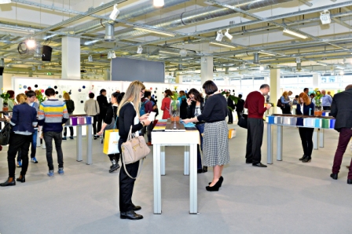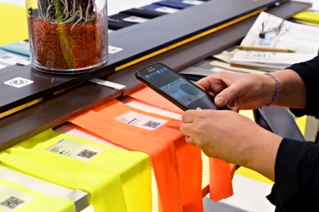
The nine categories at the PERFORMANCE FORUMs correspond to the categories in which product managers and designers think. From base layer to hard shell, all the fabrics are organized by functional range, not by some abstract trend topic.

INNOVATIONS and Accessories: Strikingly presented on the PERFORMANCE WALL:
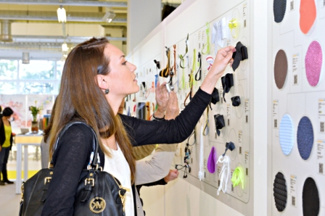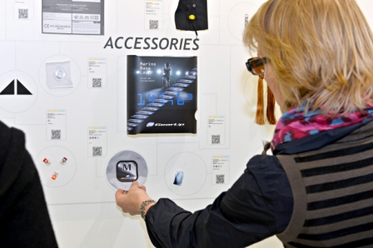
INNOVATIONS as well as accessories are presented by topic on the PERFORMANCE WALL which occupies a special place within the PERFORMANCE FORUM. This is also where the PERFORMANCE AWARD WINNER finds its rightful place.
The INNOVATIONS section proves every season anew that PERFORMANCE DAYS is the place to come to find all the very latest fabric trends.
Informative talks on all the major subjects in the industry:
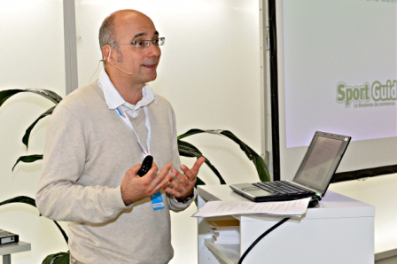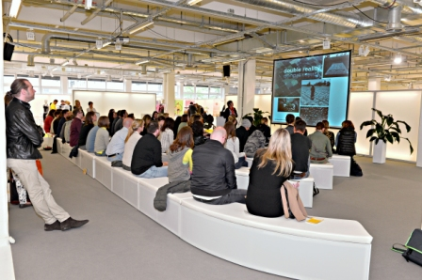
Another very special service at PERFORMANCE DAYS is the well-visited, free, English language lecture. These talks supply information about trends and novelties, illuminate important topics in the industry, and provide valuable decision making support for ordering and sampling calls.

Five good reasons to visit PERFORMANCE DAYS:
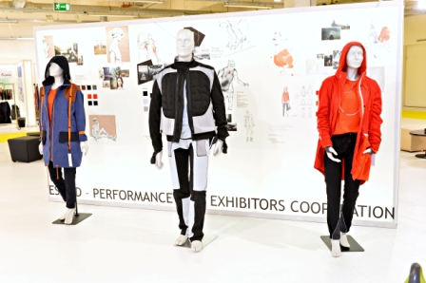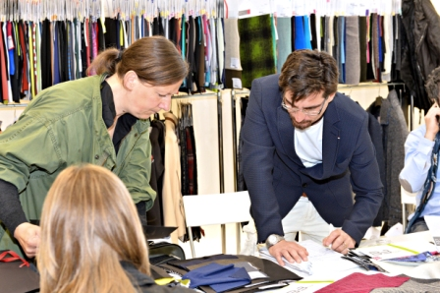
The all-round service of PERFORMANCE DAYS is what makes this trade show so popular with trade visitors. Summarized here again are the top rated items from the visitor surveys, the "hit list," so to speak:
- The high quality exhibitors
Just about every big name in the world of textile function is represented here.
2. The meaningful trend forum
As a working aid prepared in exactly the categories in which product managers think.
3. The INNOVATIONS and PERFORMANCE AWARD sections
Always with the latest developments and worthy of their names.
4. The high quality expert lectures
Free lectures are on the agenda every day and provide information about fabrics, trends, technologies, and sustainability.
5. The Outstanding service:
Whether pre-registrations online, free admission, shuttle support after the trade fair, the Fabric Library, or Store Check Guide - with a variety of services, the trade fair caters to the needs of all visitors.
Don't forget: the next PERFORMANCE DAYS are scheduled for November 4-5, 2014 in Munich!
More details about PERFORMANCE DAYS, exhibitors, and agenda for the next trade show are available online at: www.performancedays.eu, or by request to Senior Project Manager Stefanie Sacherow, s.sacherow@performancedays.eu
The photos shown plus a selection of others are also online at:
https://www.flickr.com/photos/performancedays/sets/72157644290738762/

